**Experiment # 13**

**OBJECTIVE**

To be familiar with void pointer and deference operator.

**Theory:**

**Pointer:**

A pointer is a variable that is used to store memory address. The reference operator is used to access the memory address of a variable and store it in a pointer

**Syntax**

The syntax of declaring a pointer is as follows:

Data Type *Var;

**Data Type**  It is the type of variable pointed by the pointer variable

**\***  It indicates that the variable is a pointer varaible

**Var** It is the name of the pointer variable

**Example**

#include <iostream>

#include <conio.h>

void main()

{

int n;

int *ptr;

cout<<”Enter an integer: ”;

cin >> n;

ptr = &n;

cout<<”The value of n: ”<<n<<endl;

cout<<”The address of n: ”<<ptr<<endl;

}

**The ‘void’ pointer**

The type of pointer variable and the type of variable it refers must be same. It restricts the use of a pointer variable to specific type of variable. A pointer variable can be store the address of any type of variable if it is declared as **void.**

**Example**

#include <iostream>

using namespace std;

int main() {

void* ptr;

float f = 2.3;

ptr = &f; // float* to void

cout << &f << endl;

cout << ptr;

return 0;

}

**Dereference Operator**

The Dereference operator is used to access the value of the variable whose memory address is stored in pointer. It is denoted by asterisk ‘*’. It is also called **indirection operator.**

**Example**

#include <iostream>

using namespace std;

int main() {

int *ptr,*ptr1;

int f = 2;

int f1 = 3;

ptr = &f; // float* to void

ptr1 = &f1;

int sum = *ptr + *ptr1;

cout << sum << endl;

return 0;

}

**Example**

#include<iostream>

Usingnamespacestd;  
main()  
{  
int a=1;

do

{  
cout<<a;

a++;

}  
while(a<=10);

}

**Lab Task:**

Display outputs of the above codes.

**ANSWER:**

**Example**

#include <iostream>

#include <conio.h>

void main()

{

int n;

int *ptr;

cout<<”Enter an integer: ”;

cin >> n;

ptr = &n;

cout<<”The value of n: ”<<n<<endl;

cout<<”The address of n: ”<<ptr<<endl;

}

**OUTPUT:**

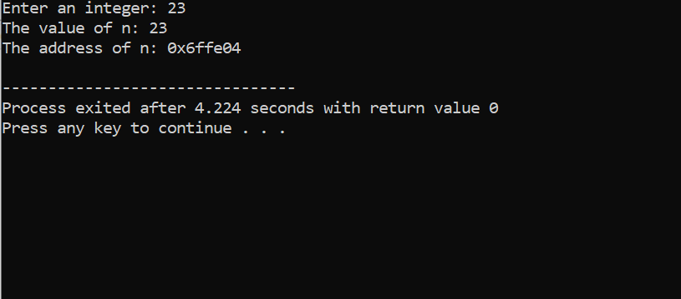

**Example**

#include <iostream>

using namespace std;

int main() {

int *ptr,*ptr1;

int f = 2;

int f1 = 3;

ptr = &f; // float* to void

ptr1 = &f1;

int sum = *ptr + *ptr1;

cout << sum << endl;

return 0;

}

**OUTPUT:**

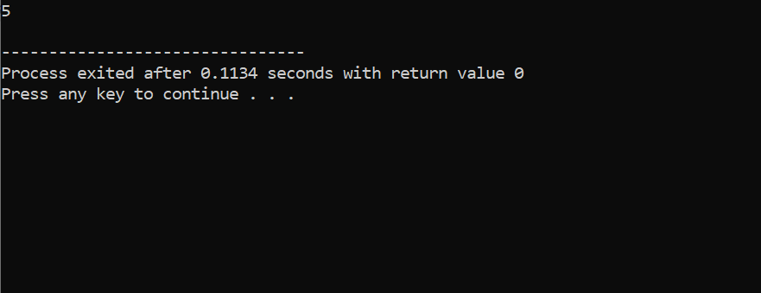

**Example**

#include<iostream>

Using namespace std;  
main()  
{  
int a=1;

do

{  
cout<<a;

a++;

}  
while(a<=10);

}

**OUTPUT:**

